**Project Design Phase-II**

**Data Flow Diagram & User Stories**

|  |  |
| --- | --- |
| Date | 19 June 2025 |
| Team ID | LTVIP2025TMID34708 |
| Project Name | Transfer Learning-Based Classification of Poultry Diseases for Enhanced Health Management |
| Maximum Marks | 4 Marks |

**Data Flow Diagrams:**

A Data Flow Diagram (DFD) is a traditional visual representation of the information flows within a system. A neat and clear DFD can depict the right amount of the system requirement graphically. It shows how data enters and leaves the system, what changes the information, and where data is stored.



**Example:** [**(Simplified)**](https://developer.ibm.com/patterns/visualize-unstructured-text/)

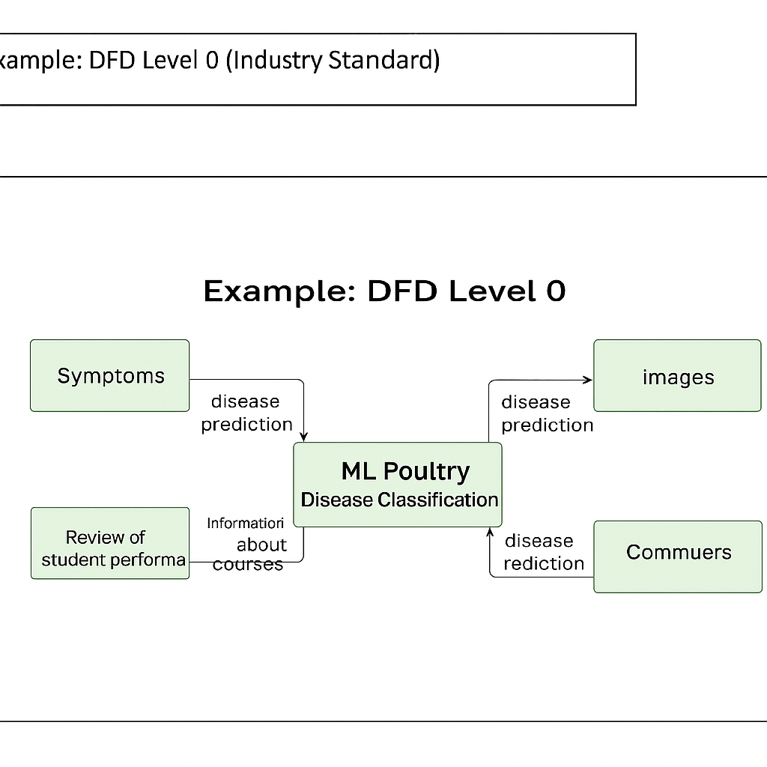

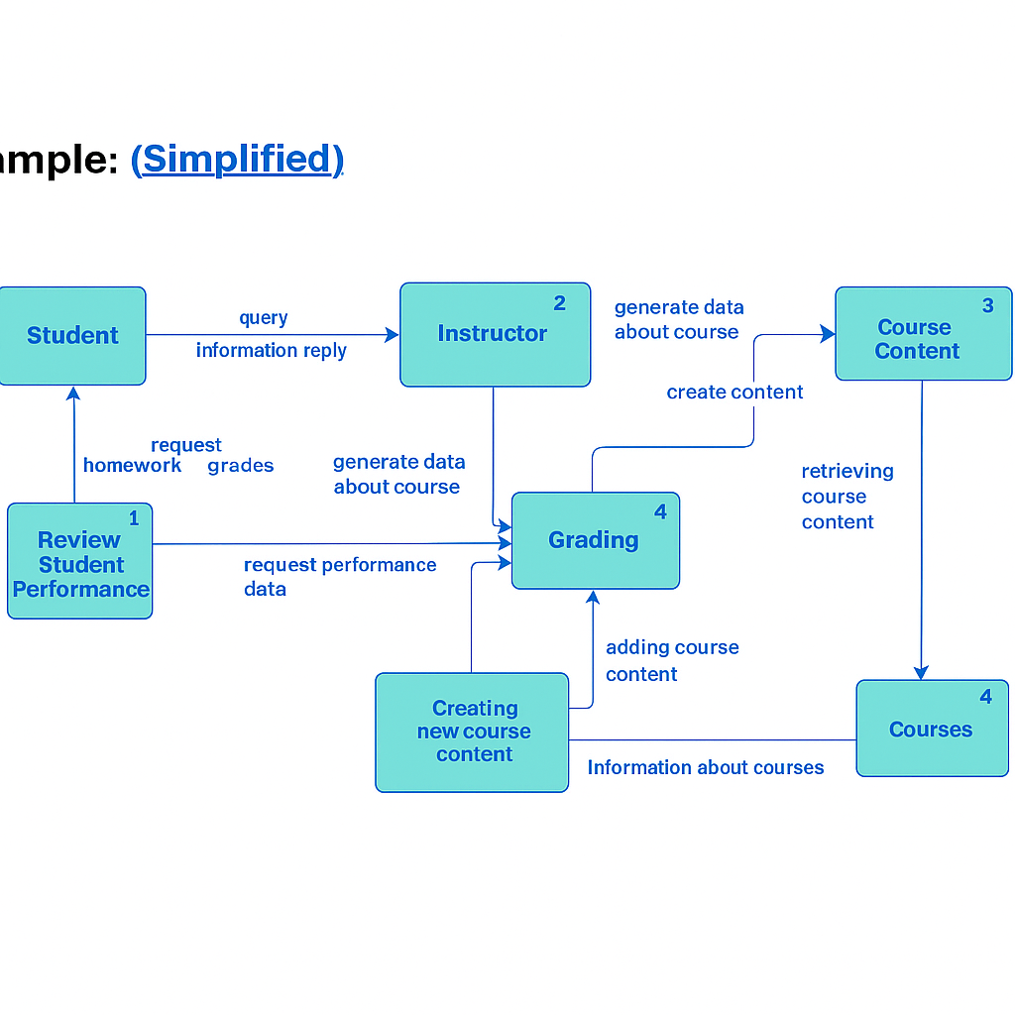

**User Stories**

Use the below template to list all the user stories for the product.

| **User Type** | **Functional Requirement (Epic)** | **User Story Number** | **User Story / Task** | **Acceptance criteria** | **Priority** | **Release** |
| --- | --- | --- | --- | --- | --- | --- |
| Data Engineer | Data Ingestion | USN-1 | As a developer, I want to collect historical poultry data from sensors and APIs | Data collected from all defined sources and stored in raw form | High | Sprint-1 |
| Data Engineer | Data Preprocessing | USN-2 | As a developer, I want to preprocess data to handle missing values and normalize formats | Clean, normalized dataset ready for modeling | High | Sprint-1 |
| ML Engineer | Model Development | USN-3 | As a data scientist, I want to build a machine learning model to predict poultry volumes | Model trained with >80% accuracy on validation set | High | Sprint-2 |
| ML Engineer | Model Evaluation | USN-4 | As a data scientist, I want to validate and test model accuracy using test datasets | Model achieves acceptable MAE/RMSE | Medium | Sprint-2 |
| DevOps | API Deployment | USN-5 | As a developer, I want to deploy the model as an API for real-time predictions | API endpoint accessible with response time <2s | High | Sprint-3 |
| Admin | Real-Time Dashboard | USN-6 | As an admin, I want to visualize real-time poultry predictions via a dashboard | Dashboard displays predictions updating live | High | Sprint-3 |
| City Planner | Urban Insights | USN-7 | As a city planner, I want to view poultry heatmaps for planning | Downloadable heatmaps by region and time | Medium | Sprint-4 |
| Commuter | Route Suggestions | USN-8 | As a commuter, I want suggested optimal routes based on live poultry | Routes adjust dynamically based on predictions | Medium | Sprint-4 |
| Third-party App | API Integration | USN-9 | As a developer, I want to integrate poultry prediction API into external apps | API returns accurate results with secure access | High | Sprint-4 |